**Software Requirement Specification Document**

**For**

**CodeGenie: Code Generation using CodeLlama**

**Prepared by**

|  |  |
| --- | --- |
| NAME | REGISTER NO |
| K. NAMITH SURYA | 23BCE7603 |
| I. HANSIKA REDDY | 23BCE7384 |
| A.R.S.E.SRI AKSHAY | 23BCE7657 |

**Introduction**

CodeGenie is a trusted software development company founded in 2017.It is headquartered in India and serves clients globally.The company offers full-cycle services in web, mobile, and custom software development.Industries served include fintech, healthcare, education, real estate, and e-commerce.

CodeGenie is known for delivering scalable and business-centric digital solutions.It builds mobile apps using Flutter, React Native, Android, and iOS technologies.Web development expertise includes Angular, React, Laravel, and Node.js. The company follows agile methodologies to ensure fast and flexible delivery.It also provides cloud integration, DevOps services, and digital transformation support.

CodeGenie places a strong focus on UI/UX design for intuitive user experiences.Clients benefit from transparent communication and a dedicated project approach.The team is made up of skilled engineers, designers, and technology consultants.They ensure solution is tailored to specific business goals and challenges.

CodeGenie is committed to quality, innovation, and long-term client success.Its mission is to empower businesses with modern, reliable, and efficient technology.

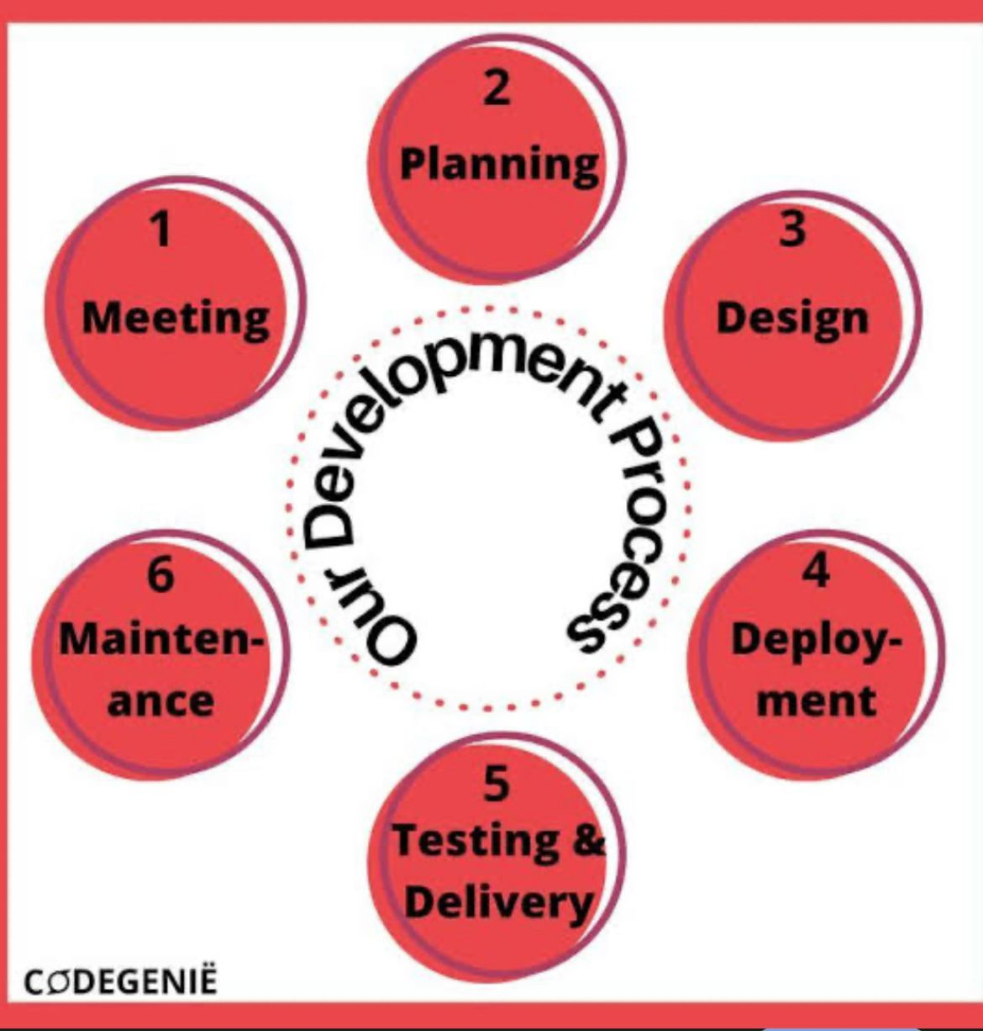

**Brainstorming & Ideation for CodeGenie: AI-Powered Code Generation using CodeLlama**

**Core Idea Recap:**CodeGenie leverages CodeLlama to generate code from natural language prompts, aiming to boost developer productivity.

**1. Core Feature Expansion & Enhancement**

* **Beyond Snippets:**
* **Function/Class Generation with Docstrings:** Generate complete functions or classes, including appropriate docstrings/comments based on prompt.
* **Microservice/API Endpoint Scaffolding:** Generate boilerplate for a specific API endpoint (e.g., a simple CRUD operation in Flask/Node.js).
* **Configuration File Generation:** Generate configuration files (e.g., docker-compose.yml, webpack.config.js, nginx.conf) from high-level requirements.
* **SQL Schema Generation:** Create SQL table schemas (DDL) from natural language descriptions of entities and relationships.
* **Regex Generator:** Generate regular expressions from examples or descriptions.
* **Shell Script Generator:** Create simple shell scripts for automation tasks.
* **Contextual Understanding & Refinement:**
* **Project Context Awareness:** If integrated with an IDE, analyze existing project files (imports, class definitions, variable names) to generate more contextually relevant code.
* **Error-Aware Generation:** Take an error message (from a compilation or runtime) and suggest code fixes or refactors.
* **Code Completion++:** Go beyond simple auto-completion; predict entire lines or blocks based on surrounding code and user intent.
* **Refinement Loop:** Allow users to provide natural language feedback on generated code (e.g., "make it more performant," "use async/await," "add error handling") to iteratively improve the output.
* **Multilingual & Framework Support:**
* **Expanded Language Support:** Consider less common but emerging languages (Rust, Kotlin, Swift) or domain-specific languages (e.g., Solidity for smart contracts).
* **Framework-Specific Generation:** Generate code tailored to specific frameworks (e.g., React components, Spring Boot controllers, Django models) by understanding framework conventions.

**2. User Experience & Interaction Paradigms**

* **Interactive Chatbot Interface:** Instead of just a single prompt box, a conversational interface where the user can refine requests, ask clarifying questions, and get explanations.
* **"Show Me How":** Users describe a task, and CodeGenie generates the code *and* explains the logic/steps involved.
* **Visual Programming Integration (Limited):** For very simple flows, perhaps allow users to drag/drop high-level concepts which then get translated into code.
* **Voice-to-Code:** Generate code using voice commands (e.g., "create a Python function to sort a list").
* **Clipboard-Awareness:** Automatically analyze code copied to the clipboard and offer contextually relevant suggestions.
* **Code "Explainer" Mode:** Highlight sections of generated code and provide natural language explanations of what they do.

**3. Collaboration & Versioning**

* **Shared Code Generation Sessions:** Allow multiple users to collaborate on code generation, similar to a collaborative document editor.
* **Version History of Generations:** Keep track of different versions of generated code for a given prompt, allowing users to revert or compare.
* **Git Integration:** Directly push generated code snippets/files to a specified Git repository branch.
* **Code Review Assistant:** Suggest improvements or potential issues in *human-written* code based on common patterns or best practices (leveraging CodeLlama's understanding of good code).

**4. Learning & Customization**

* **Fine-tuning/Personalization:** Allow users (or teams) to fine-tune the CodeLlama model on their *own* codebase to generate code that matches their internal coding style, conventions, and common patterns.
* **"Teach Me" Mode:** Users can provide a code snippet and its natural language explanation, allowing CodeGenie to learn specific idioms or patterns.
* **Code Style Enforcement:** Configure CodeGenie to generate code strictly adhering to specific style guides (e.g., PEP8 for Python, Airbnb for JavaScript).
* **Plugin/Extension Ecosystem:** Allow developers to build plugins that extend CodeGenie's capabilities (e.g., custom language support, integration with specific internal tools).

**5. Monetization & Business Models (Beyond Core Product)**

* **Freemium Model:** Basic code generation free, advanced features (larger models, more requests, fine-tuning, IDE integration) paid.
* **Subscription Tiers:** Based on usage (tokens, number of generations), model size, and features.
* **Enterprise Solutions:** On-premise deployment, dedicated support, custom model training for large organizations.
* **API Access:** Charge for API calls to CodeGenie's generation engine, allowing other tools to integrate.
* **"Prompt Library" Marketplace:** Users can share/sell effective prompts for specific tasks.
* **Code Audit/Refactoring Service:** Leveraging CodeLlama's understanding of code, offer services to analyze and suggest improvements to existing codebases.

**6. Technical Considerations & Challenges (Brainstorming Solutions)**

* **Model Latency:**
* Caching frequently requested generations.
* Optimized inference engines (e.g., ONNX Runtime, TensorRT).
* Quantization and pruning of the CodeLlama model.
* Asynchronous generation with real-time progress updates.
* **Context Window Limitations:**
* Intelligent context management (e.g., summarize large code blocks, prioritize relevant parts).
* Retrieval-Augmented Generation (RAG): Pulling relevant code snippets from a knowledge base or user's project files.
* **Hallucinations/Incorrect Code:**
* Heuristic-based validation (simple syntax checks).
* Integration with linters/formatters.
* Providing "confidence scores" for generated code.
* Strong emphasis on user feedback loop.
* **Security of User Code:**
* Strict isolation of user data.
* Opt-in mechanisms for any data used for model improvement.
* On-premise deployment options for highly sensitive environments.
* **Scalability of Model Serving:**
* Leveraging cloud-native services (Kubernetes, serverless functions).
* Dynamic provisioning of GPU resources.

**7. Marketing & Growth Strategies**

* **Developer Community Engagement:** GitHub, Stack Overflow, Reddit.
* **Open-Source Contributions:** Offer some components or tools as open-source.
* **Tutorials & Demos:** Showcasing practical use cases.
* **Integration Partnerships:** With IDEs, code editors, and other developer tools.
* **Success Stories/Case Studies:** Highlight how CodeGenie saved time/money for real users.
* **Blogging/Content Marketing:** Articles on AI in coding, productivity hacks, etc.

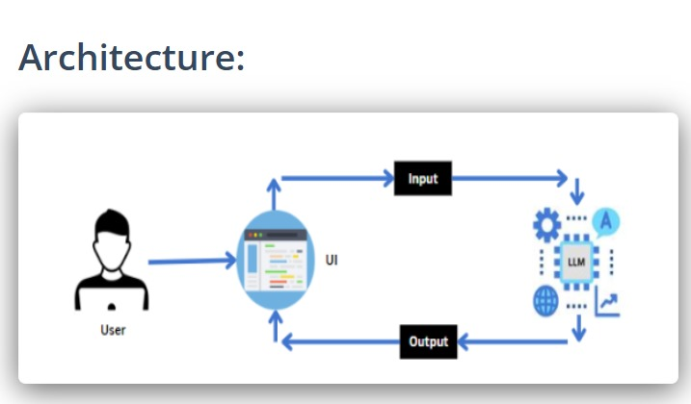

**Requirement Analysis for CodeGenie: AI-Powered Code Generation using CodeLlama**

**Project Goal:** To create an AI-powered code generation tool leveraging CodeLlama to enhance developer productivity by transforming natural language prompts into code.

**1. Stakeholder Identification & Needs Assessment**

Understanding who the system impacts and what their expectations are.

* **Primary Users (Developers/Programmers):**
* **Needs:** Fast, accurate, and contextually relevant code generation; support for multiple languages/frameworks; integration with existing workflows (IDEs); clear explanations of generated code; ability to refine/edit output; secure handling of their code/data.
* **Pain Points:** Repetitive coding tasks; debugging syntax errors; searching for boilerplate; inconsistent code styles; context switching.
* **AI/ML Engineers:**
* **Needs:** Robust API for CodeLlama interaction; efficient model serving infrastructure; mechanisms for model updates/fine-tuning; performance monitoring of the AI model.
* **Product Owners/Managers:**
* **Needs:** Clear feature definitions; project scope management; market competitiveness; user adoption metrics; roadmap for future enhancements.
* **Quality Assurance (QA) Team:**
* **Needs:** Testable requirements; clear acceptance criteria; access to testing environments; robust error logging.
* **DevOps/Infrastructure Team:**
* **Needs:** Scalable and reliable deployment; monitoring tools; secure infrastructure; efficient resource utilization (especially GPUs).
* **Technical Writers:**
* **Needs:** Clear functional descriptions; user guides; API documentation.

**2. Functional Requirements (What the System *Must Do*)**

These define the specific actions or services the system must provide.

***2.1 Code Generation Core***

* **FR-CG-100: Prompt Input:** The system shall accept natural language text input as a prompt for code generation.
* *Examples:* "Python function to reverse a string," "Java class for a simple user," "JavaScript component for a counter."
* **FR-CG-101: Language Selection:** The system shall allow users to explicitly select the target programming language (e.g., Python, Java, JavaScript, C++, C#, Go).
* **FR-CG-102: Code Generation Output:** The system shall generate and display syntactically correct code snippets, functions, or classes based on the prompt and selected language.
* **FR-CG-103: Contextual Generation (Basic):** The system shall attempt to infer context from the prompt to generate more relevant code (e.g., if "React component" is in prompt, generate JSX).
* **FR-CG-104: Multiple Variations (Optional/Stretch):** The system may offer multiple alternative code generations for a single prompt.
* **FR-CG-105: Fill-in-the-Middle (FIM) (Optional/Stretch):** The system shall allow users to provide code with a "gap" and generate content for that gap based on surrounding context.

***2.2 User Interface & Interaction***

* **FR-UI-200: Intuitive Web Interface:** The system shall provide a user-friendly web-based interface for prompt input and code display.
* **FR-UI-201: Syntax Highlighting:** Generated code shall be displayed with appropriate syntax highlighting for the selected language.
* **FR-UI-202: Copy to Clipboard:** Users shall be able to easily copy the generated code to their clipboard.
* **FR-UI-203: Prompt History:** The system shall maintain a history of user prompts and generated code for easy retrieval and re-use.
* **FR-UI-204: Feedback Mechanism:** Users shall be able to provide feedback on the quality, relevance, or correctness of generated code (e.g., thumbs up/down, comment box).
* **FR-UI-205: Prompt Refinement:** Users shall be able to edit and resubmit prompts to refine generation results.
* **FR-CU-300: Code Explanation:** The system shall provide a natural language explanation of the generated code (what it does, how it works).
* **FR-CU-301: Basic Error Highlighting:** The system shall highlight obvious syntax errors or potential issues in the generated code *before* it's copied (if detectable by a static analyzer).
* **FR-CU-302: Test Case Suggestion (Optional/Stretch):** For simple functions, the system may suggest basic unit test cases.

***2.4 User Management & Security***

* **FR-UM-400: User Registration & Login:** The system shall support user account creation and secure login.
* **FR-UM-401: Profile Management:** Users shall be able to view and update their profile information.
* **FR-UM-402: Data Privacy Controls:** Users shall have controls over how their prompt history and feedback data are used (e.g., opt-in for model training).

**3. Non-Functional Requirements (How Well the System Performs)**

These define quality attributes and constraints.

***3.1 Performance***

* **NFR-P-100: Generation Latency:** For typical prompts (1-2 sentences), code generation shall complete within 5-10 seconds.
* **NFR-P-101: Throughput:** The system shall support at least 50 concurrent code generation requests without significant performance degradation.
* **NFR-P-102: Scalability:** The system architecture shall support scaling horizontally to accommodate an increasing number of users and requests (e.g., by adding more GPU instances).
* **NFR-P-103: Resource Efficiency:** The CodeLlama inference engine should efficiently utilize allocated GPU/CPU and memory resources.

***3.2 Security***

* **NFR-S-200: Authentication:** User authentication shall be robust (e.g., multi-factor authentication optional). Passwords shall be hashed.
* **NFR-S-201: Authorization:** Users shall only be able to access their own data (prompts, generated code, profile).
* **NFR-S-202: Data Encryption:** All sensitive data (user credentials, prompt history) in transit (HTTPS/TLS) and at rest (disk encryption) shall be encrypted.
* **NFR-S-203: Input Sanitization:** All user inputs (prompts) shall be sanitized to prevent injection attacks (e.g., XSS, SQL injection).
* **NFR-S-204: AI Model Security:** Measures shall be in place to prevent prompt injection attacks or model manipulation attempts.

***3.3 Reliability***

* **NFR-R-300: Availability:** The core code generation service shall have an uptime of 99.5% (excluding scheduled maintenance).
* **NFR-R-301: Error Handling:** The system shall provide informative error messages to users and robust logging for administrators in case of failures.
* **NFR-R-302: Data Persistence:** User data (profiles, prompt history) shall be reliably stored and recoverable in case of system failure.
* **NFR-R-303: Model Stability:** The CodeLlama model serving should be stable and recover gracefully from minor interruptions.

***3.4 Usability***

* **NFR-U-400: Learnability:** A new user with basic programming knowledge should be able to generate their first code snippet within 5 minutes of accessing the platform.
* **NFR-U-401: Efficiency:** Experienced users should be able to complete a code generation task (prompt to copy) in under 30 seconds for simple requests.
* **NFR-U-402: User Experience (UX):** The UI shall be clean, uncluttered, and responsive, providing clear visual feedback for user actions.

***3.5 Maintainability***

* **NFR-M-500: Modularity:** The system shall be developed using a modular architecture to facilitate independent development, testing, and deployment of components (e.g., UI, API, AI service, database).
* **NFR-M-501: Testability:** All functional components shall be designed to be independently testable through unit, integration, and end-to-end tests.
* **NFR-M-502: Code Quality:** The codebase shall adhere to established coding standards and best practices, with sufficient inline comments and clear documentation.

***3.6 Portability***

* **NFR-PO-600: Browser Compatibility:** The web UI shall be compatible with major modern web browsers (Chrome, Firefox, Edge, Safari).
* **NFR-PO-601: Deployment Flexibility:** The backend components should be containerized (e.g., Docker) to allow for flexible deployment across various cloud providers (AWS, GCP, Azure) or on-premise environments.

**4. External Interface Requirements**

How the system interacts with the outside world.

***4.1 User Interfaces***

* **Web UI:**
* Responsive layout.
* Text area for prompt input.
* Dropdown/buttons for language selection.
* Code display area with syntax highlighting.
* Copy button.
* History section/pane.
* Feedback buttons/icons.
* Login/Registration/Profile pages.

***4.2 Hardware Interfaces***

* **GPU(s):** Requirement for NVIDIA GPUs (or compatible) with sufficient VRAM for CodeLlama model inference.
* **CPU:** Multi-core processors for application servers.
* **RAM:** Sufficient RAM for both application and model loading.
* **Storage:** SSD for faster data access and model loading.

***4.3 Software Interfaces***

* **CodeLlama Model Interface:** API or direct library calls to interact with the hosted CodeLlama model (e.g., Hugging Face Transformers library, custom inference server).
* **Database Interface:** Standard database drivers (e.g., PostgreSQL, MySQL, MongoDB drivers) for persistent data storage.
* **Authentication Service (Optional):** Integration with third-party OAuth providers (Google, GitHub) or internal authentication libraries.
* **Caching System (Optional):** Redis or Memcached for session management and caching.
* **Logging & Monitoring Tools:** Integration with Prometheus, Grafana, ELK stack.

***4.4 Communications Interfaces***

* **HTTPS/TLS:** All client-server communication must be secured using HTTPS/TLS.
* **RESTful APIs:** Backend services will expose RESTful APIs for the frontend and potential future integrations.
* **WebSockets (Optional/Stretch):** For real-time updates during lengthy generation processes or for interactive chat features.

**5. Data Model / Data Requirements (High-Level)**

* **User Data:** User ID, username, email, hashed password, registration date.
* **Prompt History:** Prompt ID, User ID, prompt text, timestamp, generated code ID(s), language.
* **Generated Code:** Code ID, generated code text, language, associated prompt ID, timestamp, feedback score,feedback data –userid,feedback id,codeid-type,optional comment.

**Project Design for CodeGenie: AI-Powered Code Generation using CodeLlama**

**Project Goal:** To design a system that effectively leverages CodeLlama to generate code from natural language prompts, providing a smooth and efficient experience for developers.

**1. Architectural Style: Microservices / Layered Architecture**

Given the distinct functionalities (UI, API, AI model serving, data storage), a **Microservices Architecture** with a clear **Layered Structure** within each service is highly suitable. This approach promotes:

* **Modularity:** Independent development and deployment of components.
* **Scalability:** Individual services can be scaled independently based on demand (e.g., AI inference service might need more resources than the UI service).
* **Technology Heterogeneity:** Different services can use different technologies optimized for their specific tasks.
* **Resilience:** Failure in one service is less likely to bring down the entire system.

**High-Level Overview:**

+----------------+ +-------------------+ +--------------------+ | | | | | | | User (Web) |------>| Frontend Service|------>| API Gateway | | | | (React/Next.js) | | (Reverse Proxy) | +----------------+ +-------------------+ +---------+----------+ | | REST/gRPC v +------------------------+ +------------------------+ +------------------------+ | | | | | | | 2. User Service | | 3. Code Generation | | 4. Data Storage Service| | (Auth, Profile, History)| | (Inference/CodeLlama)| | (DB, Vector Store) | | (Python/FastAPI, Node.js)| | (Python/FastAPI, MLFlow)| | (PostgreSQL, Redis) | +------------------------+ +------------------------+ +------------------------+ | | ^ | | | v v | +----------------------------------------------------------------+ | 5. Messaging Queue (Kafka/RabbitMQ) | +----------------------------------------------------------------+

**2. Component Breakdown & Responsibilities**

***2.1. Frontend Service (Client-Side)***

* **Responsibility:** Provides the user interface for interacting with CodeGenie.
* **Key Features:** Prompt input, language selection, displaying generated code with syntax highlighting, copy-to-clipboard, prompt history, feedback submission, user authentication UI.
* **Technology Stack (Proposed):**
* **Framework:** React / Next.js (for SSR/SEO benefits and structured development)
* **Styling:** Tailwind CSS / Material-UI
* **State Management:** React Context API / Zustand / Redux Toolkit
* **HTTP Client:** Axios / Fetch API

***2.2. API Gateway***

* **Responsibility:** Single entry point for all client requests, routes requests to appropriate backend services, handles authentication, rate limiting, and potentially logging.
* **Technology Stack (Proposed):**
* **Proxy/Gateway:** NGINX, API Gateway (AWS API Gateway, Azure API Management), Kong, Traefik
* **Authentication:** JWT verification (if using token-based auth)

**2.3. User Service**

* **Responsibility:** Manages user authentication, authorization, user profiles, and stores user-specific data like prompt history and feedback.
* **Technology Stack (Proposed):**
* **Language/Framework:** Python (FastAPI/Django REST Framework) or Node.js (Express.js)
* **Database:** PostgreSQL (for relational user data)
* **Authentication:** OAuth2 / JWT-based tokens; integration with a robust auth library (e.g., Authlib for Python, Passport.js for Node.js).

***2.4. Code Generation Service (Core AI Logic)***

* **Responsibility:** Orchestrates the interaction with the CodeLlama model. Receives prompts, passes them to the model, retrieves generated code, and performs any necessary post-processing (e.g., basic linting/formatting).
* **Technology Stack (Proposed):**
* **Language/Framework:** Python (FastAPI is excellent for ML services due to async support and Pydantic validation)
* **ML Library:** Hugging Face Transformers (for loading and running CodeLlama)
* **Inference Optimization:** DeepSpeed, vLLM, ONNX Runtime, TensorRT (for faster and more efficient GPU inference)
* **Model Serving:** NVIDIA Triton Inference Server, BentoML, MLflow Serving (for robust deployment and scaling of the CodeLlama model)

***2.5. Data Storage Service(s)***

* **Responsibility:** Persists all application data.
* **Technology Stack (Proposed):**
* **Primary Database (Relational):** PostgreSQL (for user data, prompt history, generated code metadata, feedback). Offers strong consistency and relational querying.
* **Caching/Session Store (NoSQL):** Redis (for user sessions, frequently accessed data, rate limiting counts). Offers high performance.
* **Vector Database (Future/Stretch):** Chroma, Pinecone, FAISS (for storing embeddings of code snippets for retrieval-augmented generation or code similarity search).

***2.6. Messaging Queue (Optional but Recommended for Scalability)***

* **Responsibility:** Decouples services, handles asynchronous tasks (e.g., long-running code generation, logging, feedback processing), and provides reliable communication.
* **Technology Stack (Proposed):**
* Kafka or RabbitMQ

**3. Data Flow Diagram (High-Level User Request)**

1. **User** types prompt into **Frontend Service**.
2. **Frontend Service** sends prompt to **API Gateway**.
3. **API Gateway** authenticates request, then forwards to **User Service** (to log prompt) and **Code Generation Service**.
4. **User Service** records the prompt in the **Data Storage Service (PostgreSQL)**.
5. **Code Generation Service** preprocesses the prompt.
6. **Code Generation Service** sends the prompt to the **CodeLlama Model** (via Hugging Face/Triton etc.).
7. **CodeLlama Model** generates code.
8. **Code Generation Service** receives generated code, performs post-processing (e.g., formatting), and optionally stores it in **Data Storage Service (PostgreSQL)**.
9. **Code Generation Service** returns generated code to **API Gateway**.
10. **API Gateway** sends the code back to the **Frontend Service**.
11. **Frontend Service** displays the generated code to the **User**.
12. **User** provides feedback.
13. **Frontend Service** sends feedback to **API Gateway**.
14. **API Gateway** forwards feedback to **User Service**.
15. **User Service** stores feedback in **Data Storage Service (PostgreSQL)**.

**4. High-Level Database Design (PostgreSQL)**

* **users table:**
* id (PK)
* username
* email
* password_hash
* created_at
* last_login
* is_active
* privacy_settings (JSONB for opt-in/out of data usage)
* **prompts table:**
* id (PK)
* user_id (FK to users.id)
* prompt_text
* target_language
* created_at
* generation_id (FK to generated_code.id) - if 1:1, or a separate join table for 1:M
* **generated_code table:**
* id (PK)
* prompt_id (FK to prompts.id)
* code_text
* language
* model_version
* generated_at
* feedback_score (e.g., 1-5 or boolean like/dislike)
* **feedback table:**
* id (PK)
* user_id (FK to users.id)
* generated_code_id (FK to generated_code.id)
* feedback_type (e.g., 'positive', 'negative', 'bug', 'improvement')
* comment (text)
* submitted_at

**5. Deployment Considerations**

* **Containerization:** All services (Frontend, User, Code Generation) will be containerized using Docker.
* **Orchestration:** Kubernetes (K8s) for deploying, scaling, and managing the containerized services. This is crucial for handling GPU resource allocation for the Code Generation Service.
* **Cloud Provider:** AWS, GCP, or Azure (due to their robust GPU instance offerings and managed Kubernetes services like EKS, GKE, AKS).
* **CI/CD Pipeline:** GitHub Actions, GitLab CI/CD, or Jenkins for automated testing, building, and deployment.
* **Monitoring & Logging:** Prometheus/Grafana for metrics, ELK Stack (Elasticsearch, Logstash, Kibana) or cloud-native logging services (CloudWatch, Stackdriver Logging) for centralized logging.

**6. Scalability & Performance Design Principles**

* **Stateless Services:** Design most services (especially Code Generation and Frontend) to be stateless to allow for easy horizontal scaling. Session data stored in Redis.
* **Asynchronous Processing:** Use message queues (Kafka/RabbitMQ) for long-running or background tasks (e.g., initial code generation request might be synchronous, but detailed post-processing or model fine-tuning could be asynchronous).
* **GPU Optimization:**
* Leverage efficient inference frameworks (vLLM, Triton Inference Server).
* Consider quantization and pruning of the CodeLlama model.
* Dynamic batching for inference requests.
* Auto-scaling groups for GPU instances based on load.
* **Caching:** Implement caching at various layers (CDN for static assets, Redis for database query results or frequently generated code snippets).
* **Database Scaling:** Read replicas, connection pooling, proper indexing, and query optimization for PostgreSQL.

**7. Security Design Principles**

* **Least Privilege:** Each service and user should only have the minimum necessary permissions.
* **Data Encryption:** Encrypt data in transit (TLS/HTTPS) and at rest (disk encryption for databases, S3 buckets for model weights).
* **Authentication & Authorization:** JWTs for API authentication, robust password hashing (Bcrypt), role-based access control (RBAC).
* **Input Validation & Sanitization:** Strict validation on all user inputs to prevent XSS, SQL injection, prompt injection.
* **API Security:** Rate limiting, API key management for external integrations, proper error handling to avoid information leakage.
* **Code Scanning:** Use static analysis tools in the CI/CD pipeline.
* **Regular Security Audits:** Periodically review the system for vulnerabilities.

**8. User Interface (UI) / User Experience (UX) Design Principles**

* **Simplicity & Clarity:** A clean, uncluttered interface focused on the core task of prompt input and code output.
* **Responsiveness:** Works well across various device sizes (desktop, tablet, mobile).
* **Instant Feedback:** Provide immediate visual cues for user actions (e.g., loading spinners during generation, success/error messages).
* **Syntax Highlighting:** Essential for readability of generated code.
* **Copy/Edit Functionality:** Easy ways to interact with the generated code.
* **Accessibility:** Adherence to WCAG guidelines where feasible.
* **Iterative Refinement:** Allow users to easily modify prompts or provide feedback to get better results.

**Project Planning Using Agile Methodologies at CodeGenie**

***1. Agile Planning Philosophy***

* **Iterative & Incremental:** Plan in short cycles (Sprints) and build the product incrementally.
* **Adaptive:** Be ready to change plans based on new information, feedback, or evolving requirements (e.g., new insights from CodeLlama's capabilities).
* **Collaborative:** Involves the entire Scrum Team (Product Owner, Development Team, Scrum Master) and stakeholders.
* **Customer-Centric:** Focus on delivering features that provide the most value to the end-users (developers).
* **Just-in-Time Planning:** Detail planning happens closer to when the work is done, reducing waste from planning for features that might change or become irrelevant.

***2. Levels of Agile Planning for CodeGenie***

Agile planning occurs at multiple levels, each with a different time horizon and level of detail:

**2.1. Strategic Planning: Product Vision & Roadmap (Long-Term - 6-12+ months)**

* **Purpose:** Define the overarching goal and direction for CodeGenie.
* **Activity:**
* **Product Vision Statement:** A concise statement outlining what CodeGenie aims to achieve.

*Example for CodeGenie:* "To empower developers by providing an intelligent, efficient, and reliable AI-powered code generation assistant that significantly reduces development time and improves code quality, leveraging the latest advancements in large language models like CodeLlama."

* **Product Roadmap:** A high-level, visual timeline that outlines the major features (Epics or Themes) that CodeGenie will deliver over time. It's not a rigid schedule but a guide.
* *Example Themes:* Core Code Generation, IDE Integrations, User Customization/Fine-tuning, Code Analysis & Refactoring, Advanced Language Support.
* **Participants:** Product Owner, key Stakeholders, Scrum Master, Lead Developers.
* **Artifacts:** Product Vision Statement, Product Roadmap.

**2.2. Release Planning (Mid-Term - 2-6 Sprints / 1-3 months)**

* **Purpose:** Define the features that will be included in the next major release of CodeGenie and estimate when it can be delivered.
* **Activity:**
* **Select Release Goal:** What is the primary objective of this release? (e.g., "Launch V1 with core Python/Java generation and basic history").
* **Identify Epics/Features:** Pull high-priority Epics/User Stories from the top of the Product Backlog.
* **Estimate Velocity:** Based on past Sprints, determine the team's average capacity (e.g., "we typically complete 25 story points per Sprint"). If no past data, make an initial conservative estimate.
* **Allocate Features to Sprints:** Map the selected features to a series of upcoming Sprints, considering the team's estimated velocity.
* **Participants:** Product Owner, Development Team, Scrum Master.
* **Artifacts:** Release Goal, Estimated Release Date, High-level Release Backlog.

**2.3. Iteration Planning: Sprint Planning (Short-Term - Per Sprint, e.g., 2 weeks)**

* **Purpose:** Detail the work to be done in the upcoming Sprint. This is where high-level requirements are broken down into actionable tasks.
* **Activity:** (As described in the Agile Diagram)
* **Product Backlog Refinement/Grooming (Ongoing):** The Product Owner and Development Team regularly meet throughout the Sprint to elaborate on upcoming Product Backlog items, add details, estimate them (using techniques like Story Points, Planning Poker), and ensure they are ready for Sprint Planning.
* *For CodeGenie:* Refine user stories like "As a Python developer, I want to generate a requests call given a URL and parameters," adding acceptance criteria (e.g., "Must handle GET/POST," "Must include error handling").
* **Sprint Goal Definition:** The team agrees on a clear, achievable goal for the Sprint.
* **Sprint Backlog Creation:** The Development Team selects items from the refined Product Backlog and breaks them down into smaller, estimated tasks.

*Example Tasks for CodeGenie:* "Set up CodeLlama inference environment," "Develop UI component for prompt input," "Implement API endpoint for code generation," "Write unit tests for prompt validation."

* **Commitment:** The team commits to delivering the Sprint Goal and the selected Sprint Backlog items.
* **Participants:** Product Owner, Development Team, Scrum Master.
* **Artifacts:** Sprint Goal, Sprint Backlog (detailed tasks with estimates).

**2.4. Daily Planning: Daily Scrum (Very Short-Term - Daily)**

* **Purpose:** To synchronize activities and create a plan for the next 24 hours.
* **Activity:** (As described in the Agile Diagram)
* Each team member shares what they did, what they will do, and any impediments.
* Quick adjustments to the daily plan are made to ensure the Sprint Goal remains on track.
* **Participants:** Development Team, Scrum Master (facilitator), Product Owner (optional listener).
* **Artifacts:** Implicit adjustments to the Sprint Backlog and individual tasks.

***3. Key Agile Planning Activities & Tools for CodeGenie***

* **User Stories:** Capture requirements from the user's perspective.
* *Format:* "As a [role], I want [feature] so that [benefit]."
* *Example for CodeGenie:* "As a Java developer, I want to input a natural language description of a complex

algorithm so that CodeGenie generates a working Java implementation."

* **Epics:** Large user stories that can be broken down into smaller ones. (e.g., "IDE Integration" Epic).
* **Story Points / Planning Poker:** A relative estimation technique used by the Development Team to estimate the effort/complexity of User Stories. (e.g., "Generating a simple Python function" might be 3 points, "Integrating with VS Code" might be 13 points).
* **Kanban Boards (or Scrum Boards):** Visual tools (physical or digital like Jira, Trello, Azure DevOps) to track the flow of work (To Do, In Progress, Done).
* **Burndown Charts:** Track remaining work in a Sprint or Release against time to monitor progress and predict completion.
* **Velocity Charts:** Track the amount of work (in Story Points) a team consistently completes per Sprint, used for future release planning.
* **Retrospectives:** Crucial for improving the planning process itself. Regularly ask: "Are our planning meetings effective? Are our estimations accurate? Are we grooming the backlog enough?"

***4. Adapting Agile for CodeGenie's AI Component***

* **Experimentation Sprints:** Dedicate specific Sprints to R&D for the AI model (e.g., "Experiment with CodeLlama fine-tuning on custom datasets," "Benchmark different inference optimizations"). These might not produce direct user-facing features but are crucial for future capabilities.
* **Risk-Driven Sprints:** Address high-risk technical aspects early (e.g., "Prove out CodeLlama model serving scalability").
* **Feedback Loops for AI:** Design explicit feedback mechanisms in the UI to collect data that can be used to improve the CodeLlama model or subsequent versions. This feedback should directly influence future Product Backlog items related to model accuracy or refinement.
* **Incremental Model Deployment:** Instead of a "big bang" model update, consider continuous integration and deployment of minor model improvements.

By adopting this agile planning approach, the CodeGenie project can remain flexible, responsive to evolving technical challenges and user needs, and consistently deliver valuable features in an iterative manner.

**Project Development for CodeGenie using Agile Methodologies**

The development process for CodeGenie is centered around **Sprints**, where the cross-functional Development Team works collaboratively to transform Sprint Backlog items into a "Done," potentially shippable increment.

***1. Core Development Loop within a Sprint***

Each Sprint (e.g., 2 weeks) for CodeGenie follows a consistent pattern:

**1.1. Sprint Planning Output Review**

* At the start of the Sprint, the team has its **Sprint Backlog** (selected user stories and their broken-down tasks) and a clear **Sprint Goal**.
* Developers pick tasks from the Sprint Backlog that align with their skills and the Sprint Goal.

**1.2. Task Breakdown & Estimation (Continuous)**

* Even if tasks were initially broken down in Sprint Planning, developers further refine them as they start working.
* They might break a task like "Implement Code Generation API Endpoint" into:
* "Define API schema for prompt input."
* "Integrate FastAPI route for code generation."
* "Call CodeLlama inference module."
* "Handle model response formatting."
* "Add unit tests for API endpoint.

**1.3. Coding and Implementation**

* Developers write code based on the detailed tasks, adhering to agreed-upon coding standards and architectural guidelines.
* They use their chosen IDEs (e.g., VS Code, IntelliJ) and interact with the Version Control System (VCS).

**1.4. Continuous Testing (Test-Driven Development - TDD / Behavior-Driven Development - BDD)**

* **Unit Testing:** Developers write automated tests for individual functions, methods, or components *before* or *while* writing the actual code. This ensures correctness at the smallest granular level.
* *For CodeGenie:* Testing prompt parsing logic, utility functions, specific CodeLlama model outputs for known inputs.
* **Integration Testing:** As components are built, they are tested together to ensure they interact correctly (e.g., Frontend communicating with Backend API, Backend API calling the CodeLlama inference service).
* **API Testing:** Automated tests for all API endpoints to ensure they respond correctly and handle various inputs/outputs.

**1.5. Daily Scrum (Inspect & Adapt)**

* Every day, the team inspects their progress towards the Sprint Goal.
* Impediments are identified and the Scrum Master works to remove them.
* Plans for the next 24 hours are adjusted. This ensures rapid adaptation to challenges or new insights.

**1.6. Collaboration & Communication**

* **Pair Programming:** Two developers work at one workstation, collaborating on coding tasks. Highly effective for knowledge sharing and immediate code review.
* **Code Reviews:** Completed code is peer-reviewed (e.g., via Pull Requests in Git). This catches bugs early, ensures code quality, and spreads knowledge.
* *For CodeGenie:* Reviewing how prompts are handled, how CodeLlama is invoked, error handling in generated code.
* **Ad-hoc Discussions:** Constant communication within the team to clarify requirements, solve technical problems, and share progress.

**1.7. Definition of "Done"**

* A crucial aspect. Before a Sprint Backlog item is considered "Done," it must meet a predefined set of criteria.
* *Example Definition of Done for CodeGenie:*
* Code written and reviewed.
* Unit tests passed (100% coverage for critical paths).
* Integration tests passed.
* Code formatted according to standards (e.g., Black for Python).
* Security checks passed (basic static analysis).
* Documentation updated (e.g., API docs, inline comments).
* Demonstrable functionality ready for Sprint Review.
* Deployed to a staging/testing environment.

***2. Specific Development Workflows for CodeGenie Components***

**2.1. AI/ML Model Development & Integration**

* **Model Management:** Using MLOps tools (e.g., MLflow, DVC) to track CodeLlama model versions, training runs, and experiment results.
* **Inference Optimization:** Work on quantizing, pruning, and using specialized inference engines (Triton, vLLM) to meet performance NFRs for code generation latency.
* **Model Fine-tuning (Iterative):** As user feedback is collected (from FR-UI-204), the AI/ML engineers will periodically retrain or fine-tune CodeLlama on relevant datasets to improve accuracy and relevance. This might be a separate, longer "AI/ML Sprint" or a continuous background process.
* **Prompt Engineering:** Iteratively refining the prompts sent to CodeLlama to get the best possible output for various user requests.

**2.2. Frontend Development**

* **Component-Based Development:** Building reusable UI components (e.g., Code Editor component, Prompt Input component, History List).
* **State Management:** Efficiently handling application state (user input, loading states, generated code).
* **UX Implementation:** Ensuring smooth animations, responsive design, and intuitive interactions based on UI/UX design principles.

**2.3. Backend Development**

* **API Design & Implementation:** Building robust, secure, and performant RESTful APIs using FastAPI or a similar framework.
* **Database Interactions:** Designing and implementing efficient data models and database queries.
* **Security Implementation:** Incorporating authentication, authorization, input validation, and secure coding practices.
* **Error Handling:** Implementing comprehensive error logging and graceful error responses.

**2.4. DevOps & Infrastructure Development**

* **Automated Builds:** Setting up CI/CD pipelines to automatically build, test, and package CodeGenie components upon code commits.
* **Containerization:** Writing Dockerfiles for all services.
* **Deployment Automation:** Scripting deployment to Kubernetes clusters (e.g., Helm charts).
* **Monitoring & Alerting:** Setting up dashboards and alerts to monitor service health, performance, and resource utilization (especially GPU usage).
* **Infrastructure as Code (IaC):** Using tools like Terraform or CloudFormation to provision and manage cloud infrastructure.

***3. Tools and Environment***

* **Version Control:** Git (e.g., GitHub, GitLab, Bitbucket) for collaborative code management.
* **CI/CD:** GitHub Actions, GitLab CI/CD, Jenkins, Azure DevOps Pipelines.
* **IDEs/Editors:** VS Code, PyCharm, IntelliJ IDEA.
* **Collaboration Tools:** Slack, Microsoft Teams for quick communication; Jira, Trello, Azure DevOps Boards for task tracking.
* **Containerization:** Docker.
* **Orchestration:** Kubernetes.
* **Monitoring:** Prometheus, Grafana, ELK Stack.

By following this disciplined yet flexible development process, the CodeGenie team can continuously build, integrate, and deliver high-quality software features in response to evolving requirements and user feedback.

**Functional and Performance Testing for CodeGenie**

***1. Functional Testing***

**Purpose:** To verify that each function and feature of CodeGenie operates in conformance with the specified requirements and user expectations. It ensures "does the system do what it's supposed to do?"

Approach:

Functional testing for CodeGenie will be integrated throughout the Agile development sprints, with a strong emphasis on automation and continuous feedback.

**1.1. Levels of Functional Testing**

* **Unit Testing:**
* **Focus:** Individual units or components of code (functions, methods, classes).
* **Executed By:** Developers.
* **CodeGenie Application:**
* Testing individual utility functions (e.g., prompt parsing, string manipulation).
* Testing specific logic within API endpoints (e.g., input validation).
* Testing UI components in isolation (e.g., button clicks, input field states).
* Testing the logic for interacting with the CodeLlama model (mocking the model response).
* **Tools:** Jest (JavaScript/React), PyTest (Python), JUnit (Java).
* **Integration Testing:**
* **Focus:** Interactions between different modules or services.
* **Executed By:** Development Team / QA Team.
* **CodeGenie Application:**
* Frontend to Backend API communication (e.g., verifying prompt submission and code display).
* Backend API to User Service communication (e.g., user login, history saving).
* Backend API to Code Generation Service communication (e.g., sending prompt, receiving generated code).
* Database interactions (e.g., ensuring data is correctly stored and retrieved for user profiles, prompts, and feedback).
* **Tools:** Postman, PyTest with requests, Supertest (Node.js), Cypress, Playwright.
* **System Testing:**
* **Focus:** The complete integrated CodeGenie system, verifying end-to-end scenarios against requirements.
* **Executed By:** QA Team.
* **CodeGenie Application:**
* **Core Flow:** User logs in -> inputs prompt -> selects language -> submits -> sees generated code -> copies code -> logs out.
* **Edge Cases:** Long prompts, invalid language selections, network errors during generation, empty prompts.
* **Error Handling:** Verifying appropriate error messages are displayed for user errors or system failures.
* **Security Testing (Basic Functional):** Testing user authentication and authorization flows, ensuring data isolation between users.
* **Tools:** Selenium, Cypress, Playwright (for E2E UI automation), Postman/Newman (for API collection automation).
* **User Acceptance Testing (UAT):**
* **Focus:** Validating the system against business requirements and ensuring it meets the needs of the end-users (developers) in a real-world context.
* **Executed By:** End-users, Product Owner, Stakeholders.
* **CodeGenie Application:**
* Beta testing with a group of target developers.
* Gathering feedback on the relevance and utility of generated code.
* Assessing the overall user experience and workflow integration.
* Verifying that the generated code is truly helpful and reduces development time.
* **Tools:** User surveys, feedback sessions, internal dogfooding.

**1.2. Key Functional Test Cases (Examples for CodeGenie)**

* **Prompt Input:**
* Validate maximum prompt length.
* Test various prompt complexities (simple, complex, ambiguous).
* Test prompts with specific language cues (e.g., "Python function to...").
* **Language Selection:**
* Verify all supported languages generate appropriate syntax.
* Test changing language mid-session.
* **Code Generation:**
* Verify generated code is syntactically correct for the chosen language.
* Verify generated code aligns semantically with the prompt.
* Test for code style adherence (if configured).
* Test generation of different code structures (function, class, snippet).
* **UI/UX:**
* Ensure syntax highlighting works correctly.
* Verify copy-to-clipboard functionality.
* Test prompt history display and retrieval.
* Verify feedback submission flow.
* Test responsiveness across devices.
* **User Management:**
* Successful user registration, login, logout.
* Password reset functionality.
* Profile update.
* **Error Handling:**
* Test network disconnections during generation.
* Test for backend service unavailability.
* Test for invalid API requests.

***2. Performance Testing***

**Purpose:** To evaluate the responsiveness, stability, scalability, and resource utilization of CodeGenie under various load conditions. It answers "how well does the system perform under stress?"

**Approach:** Performance testing will simulate real-world usage patterns to identify bottlenecks and ensure the system meets its Non-Functional Requirements (NFRs).

**2.1. Types of Performance Testing**

* **Load Testing:**
* **Focus:** Verify system behavior under expected normal and peak user loads.
* **CodeGenie Application:** Simulate concurrent users submitting prompts, logging in, accessing history. Crucially, measure **code generation latency** under these conditions.
* **Metrics:** Average response time for generation, throughput (requests/sec), error rate.
* **Stress Testing:**
* **Focus:** Determine the system's breaking point by pushing it beyond normal load capacity, identifying resource exhaustion and recovery.
* **CodeGenie Application:** Gradually increase the number of concurrent users and generation requests until the system's performance degrades unacceptably or it crashes. Monitor GPU/CPU/RAM utilization closely.
* **Metrics:** Failure rate, resource saturation levels, time to recover.
* **Spike Testing:**
* **Focus:** Test system behavior under sudden, large increases in load over a short period.
* **CodeGenie Application:** Simulate a sudden surge in prompt submissions (e.g., during a popular live coding event).
* **Soak/Endurance Testing:**
* **Focus:** Check system stability and performance over a prolonged period (e.g., 24-48 hours) to detect memory leaks, resource exhaustion, or degradation over time.
* **CodeGenie Application:** Run a continuous moderate load of generation requests for an extended period.

**2.2. Key Performance Metrics for CodeGenie**

* **Code Generation Latency:** The time taken from prompt submission to receiving the generated code. (Crucial NFR: e.g., 5-10 seconds for simple prompts).
* **Throughput:** Number of successful code generation requests (or API calls) per second.
* **Concurrent Users:** Maximum number of users the system can handle simultaneously without significant performance degradation.
* **Resource Utilization:** CPU, Memory, Network I/O, **GPU Utilization & VRAM consumption** (critical for CodeLlama inference).
* **Error Rate:** Percentage of failed requests under load.

**2.3. Specific Performance Challenges for CodeGenie (AI-Powered)**

* **GPU Bottlenecks:** CodeLlama inference is highly reliant on GPUs. Performance testing must thoroughly evaluate GPU capacity, VRAM, and processing power.
* **Model Loading Time:** Initial loading of the CodeLlama model into memory can be slow. This impacts cold-start latency.
* **Context Window Size:** Larger prompts/context can increase inference time and memory usage.
* **Concurrency for AI Models:** Efficiently managing multiple inference requests on limited GPU resources (batching, queuing).
* **Fine-tuning Impact:** How frequent model updates/fine-tuning impact overall system performance and deployment pipeline.

**2.4. Performance Testing Tools**

* **Load Generation:**
* **JMeter:** Open-source, widely used for API and web load testing.
* **Gatling:** Scala-based, powerful for scripting complex scenarios.
* **Locust:** Python-based, easy to write test scripts.
* **k6:** JavaScript-based, excellent for modern web applications.
* **Monitoring:**
* **Prometheus & Grafana:** For collecting and visualizing metrics (CPU, RAM, network, custom application metrics, GPU metrics via NVIDIA DCGM Exporter).
* **Cloud Provider Monitoring:** AWS CloudWatch, GCP Monitoring, Azure Monitor.
* **APM Tools:** New Relic, Datadog (for deeper application insights).

By thoroughly executing these functional and performance testing strategies, the CodeGenie team can ensure that the application is robust, reliable, and provides an excellent user experience, truly leveraging the power of CodeLlama for developers.

**CODEGENERATION SAMPLE:**

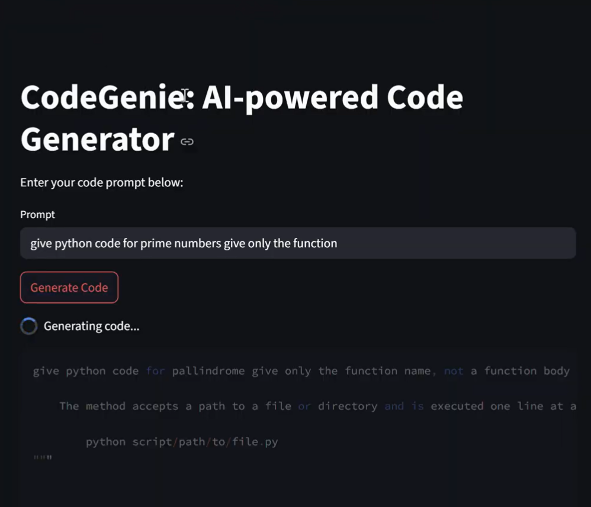

**OUTPUT**:

